**Reinforcement Learning Coursework 3**

**WU Zhi 17040772** [**UCABWUA@UCL.AC.UK**](mailto:UCABWUA@UCL.AC.UK)

**Department of Computer Science**

**University College London**

# Part 1: Implement Agents

## 1.2 Linear Model

The parameters of all these linear transformations must be trained by gradient descent. Write down the update to the parameters of the models and implement the update in the model below.

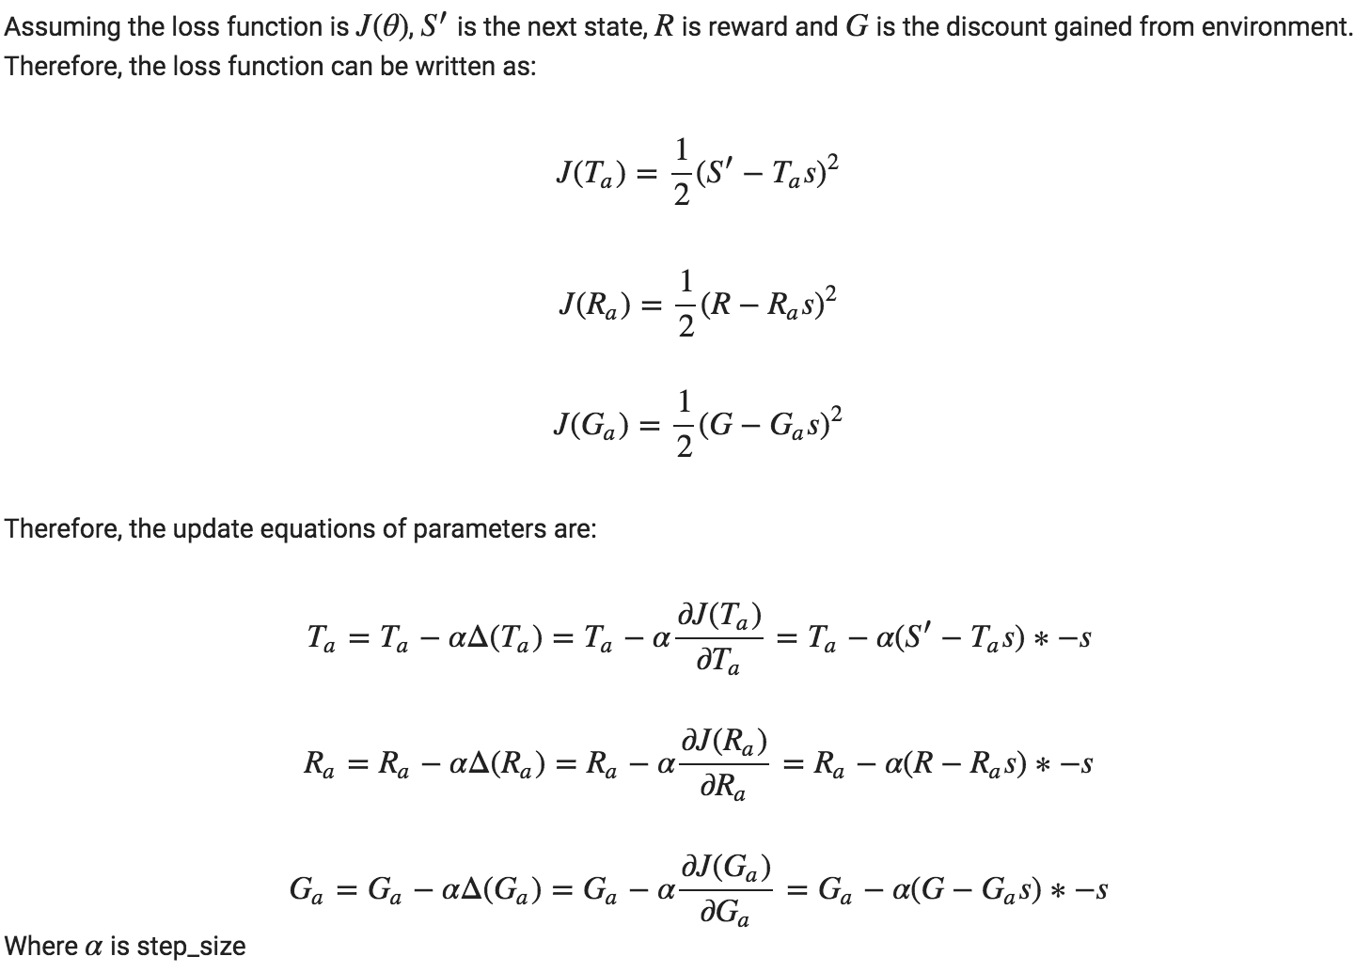

# Part 2: Analyse Results

## 2.1 Tabular Learning

### 2.1.1 Data Efficiency

Online Q-learning



Experience Replay



DynaQ



### 2.1.2 Computational Cost

Online Q-learning

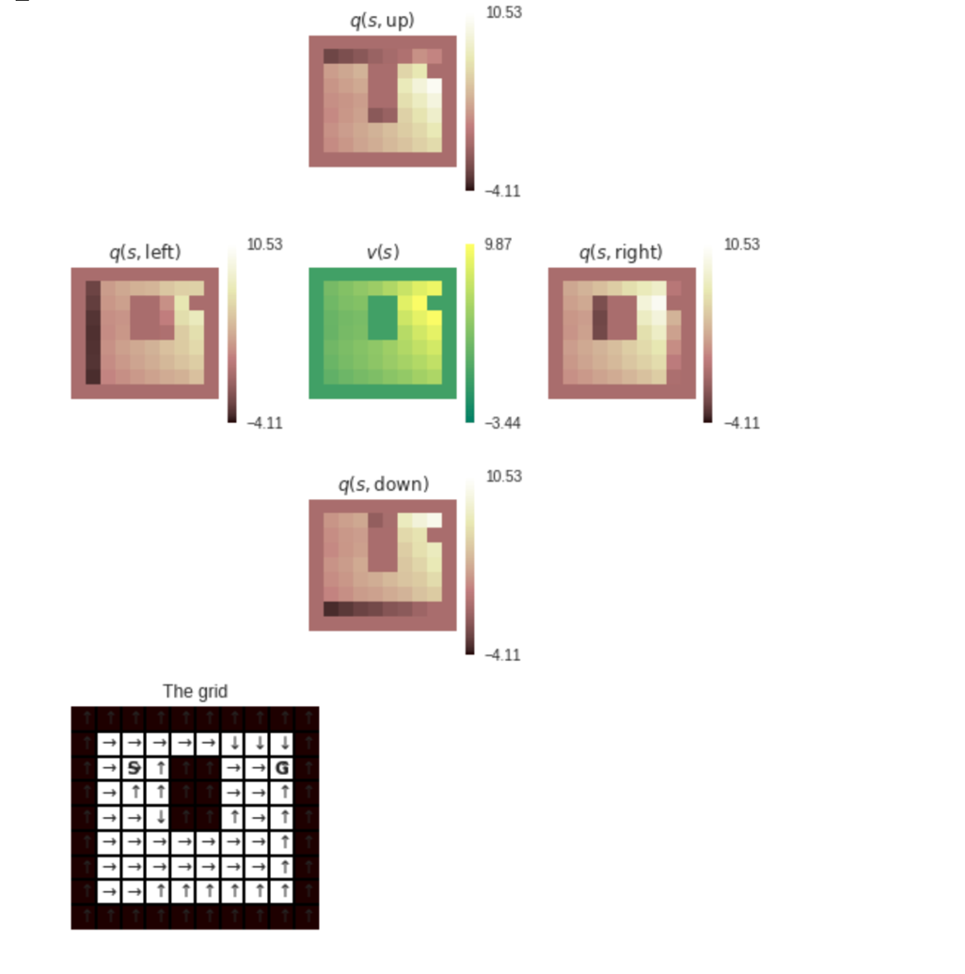

Experience Replay

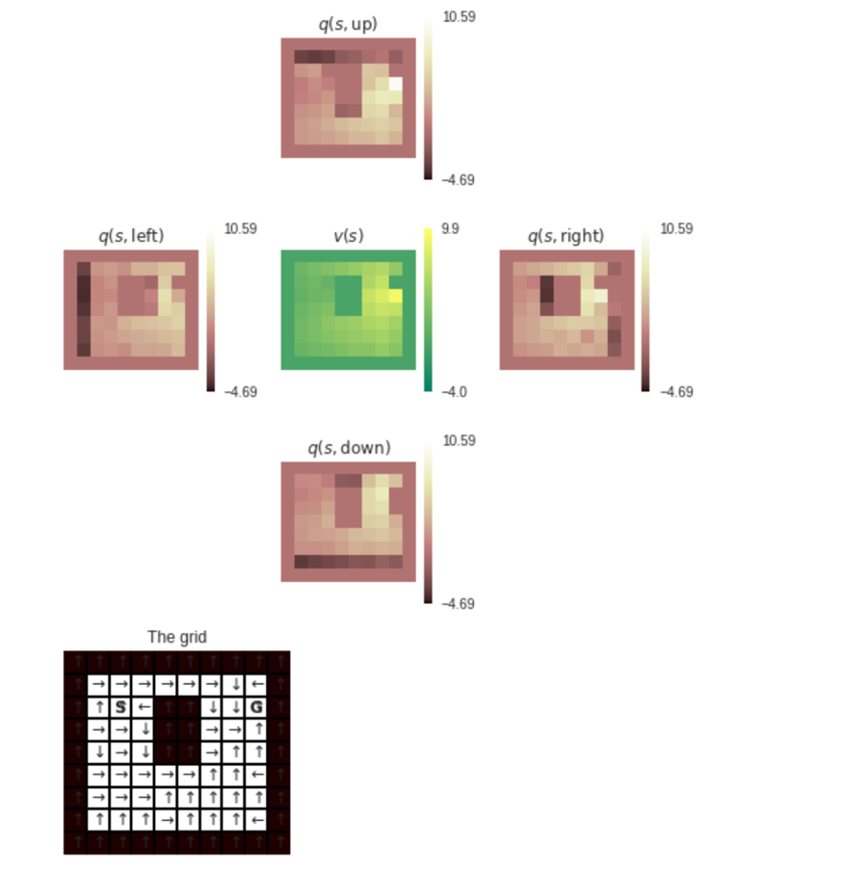

DynaQ

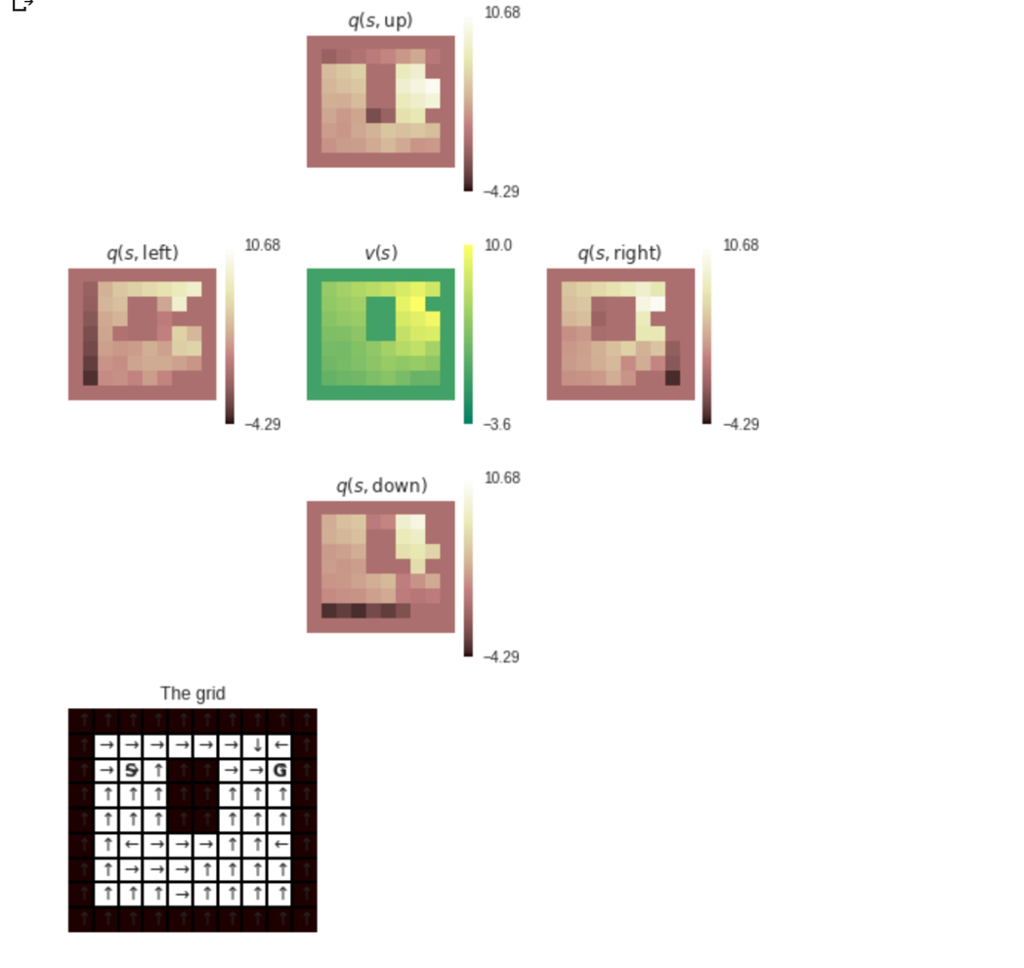

## 2.3 Linear function approximation

Online Q-learning with Linear Function Approximation

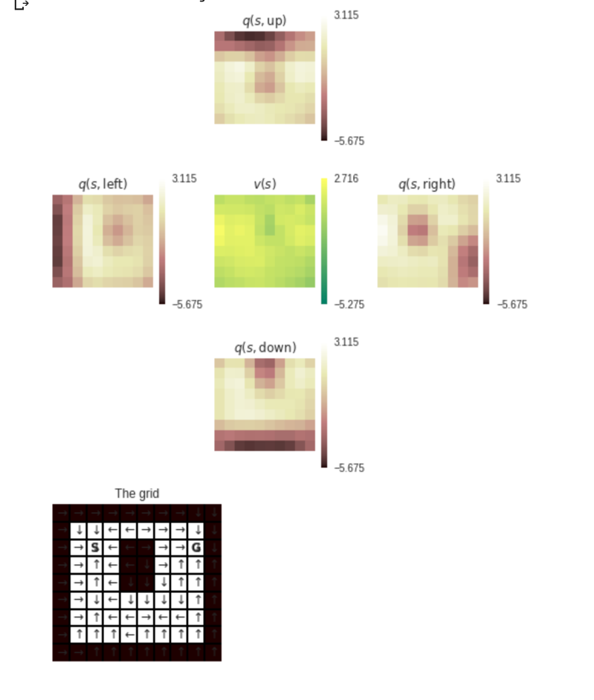

Experience Replay with Linear Function Approximation

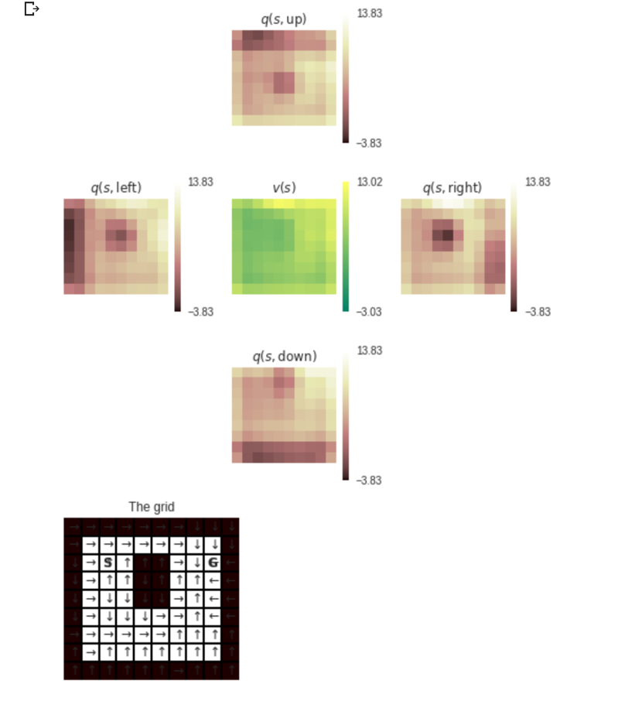

DynaQ with Linear Function Approximation

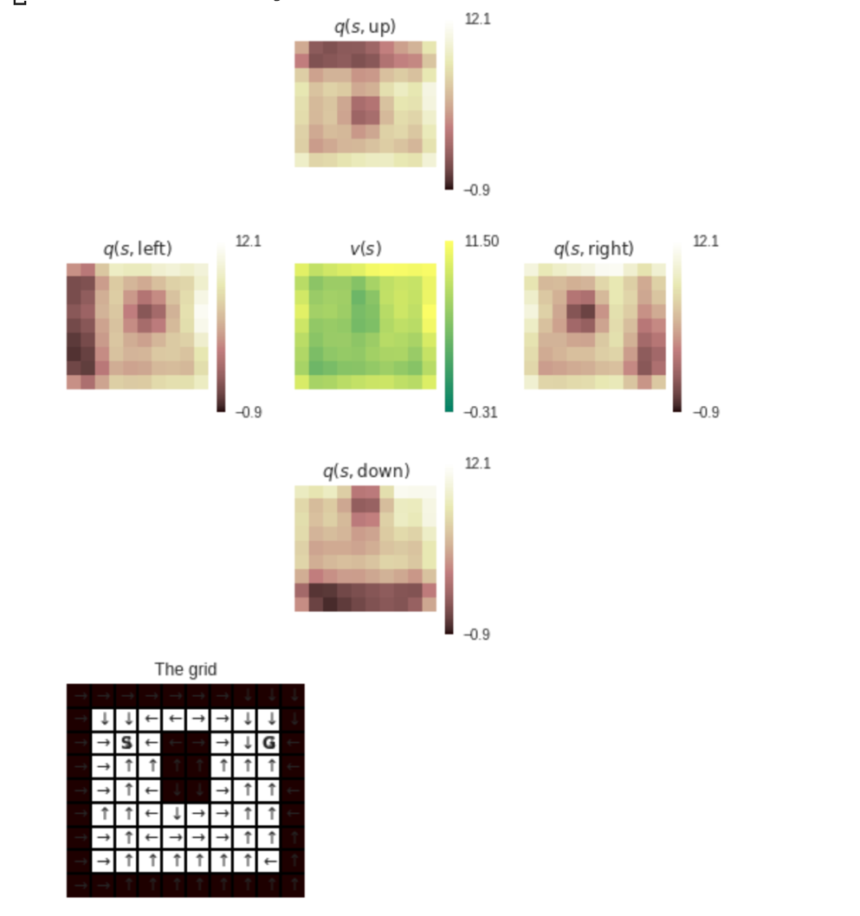

## 2.4 Non stationary Environments

Online Q-learning



Experience Replay



Dyna



### Question



